PERSONAL EXPENSE TRACKER USING PYTHON

MINOR PROJECT REPORT

By

**NITIN ANAND (RA2211003010285)**

**AKSHAT SHARMA (RA22211003010289)**

Under the guidance of   
**Dr. Ajanthaa Lakkshmanan***In partial fulfilment for the Course*

of

**21CSC203P – ADVANCED PROGRAMMING PRACTICE**

in **Department of Computing Technologies**



**FACULTY OF ENGINEERING AND TECHNOLOGY**

**SCHOOL OF COMPUTING**

**SRM INSTITUTE OF SCIENCE AND TECHNOLOGY**

**KATTANKULATHUR**

**NOVEMBER 2023**

**SRM INSTITUTE OF SCIENCE AND TECHNOLOGY**

**(Under Section 3 of UGC Act, 1956)**

**BONAFIDE CERTIFICATE**

Certified that this minor project report for the course **21CSC203P** **ADVANCED PROGRAMMING PRACTICE** entitled in "**GROUP CHAT APPLICATION**" is the bonafide work of  **Nitin Anand (RA2211003010285)** and **Akshat Sharma (RA2211003010289)** who carried out the work under my supervision.

# SIGNATURE SIGNATURE

Dr. Ajanthaa Lakkshmanan Dr. M. Pushpalatha

# Assistance Professor Head of Department

**C. Tech C. Tech**

SRM Institute of Science and Technology SRM Institute of Science and Technology

Kattankulathur Kattankulathur

# ABSTRACT

The web application “Expense Tracker” is developed to manage the daily expenses in a more efficient and manageable way. By using this application we can reduce the manual calculations of the daily expenses and keep track of the expenditure. In this application, user can provide his income to calculate his total expenses per day and these results will be stored for each user. The application has the provision to predict the income and expense for the manager using data mining. In this application, there are 3 logins such as admin, manager and staff. Admin has the privilege to add, edit, delete manager, add, edit, delete staff, and to get all custom reports. For Manager, the privileges are to add type of expense, verify expense, add type of income, verify income and generate reports. For staff, the privileges are to add and edit expense, income and calculations, and send for verifications.

# ACKNOWLEDGEMENT

We express our heartfelt thanks to our honorable **Vice Chancellor Dr. C. MUTHAMIZHCHELVAN**, for being the beacon in all our endeavors.

We would like to express my warmth of gratitude to our **Registrar Dr. S. Ponnusamy,** for his encouragement.

We express our profound gratitude to our **Dean (College of Engineering and Technology) Dr. T. V. Gopal,** for bringing out novelty in all executions.

We would like to express my heartfelt thanks to Chairperson, School of Computing **Dr. Revathi Venkataraman,** for imparting confidence to complete my course project

We wish to express my sincere thanks to **Course Audit Professors Dr. Vadivu. G, Professor, Department of Data Science and Business Systems and Dr. Sasikala. E Professor, Department of Data Science and Business Systems** and **Course Coordinators** for their constant encouragement and support.

We are highly thankful to our my Course project Faculty **Dr. Ajanthaa Lakkshmanan, Assistance Professor, C. Tech,** for his/herassistance, timely suggestion and guidance throughout the duration of this course project.

We extend my gratitude to our **HOD, Dr. M. Pushpalatha, HOD, C.Tech** and my Departmental colleagues for their Support.

Finally, we thank our parents and friends near and dear ones who directly and indirectly contributed to the successful completion of our project. Above all, I thank the almighty for showering his blessings on me to complete my Course project.

**TABLE OF CONTENTS**

|  |  |  |  |
| --- | --- | --- | --- |
| **CHAPTER NO** | | **CONTENTS** | **PAGE NO** |
| **1** | **INTRODUCTION** | | **6** |
|  | 1.1 Motivation | |  |
|  | 1.2 Objective | |  |
|  | 1.3 Problem Statement | |  |
|  | 1.4 Challenges | |  |
| **2** | **LITERATURE SURVEY** | | **9** |
| **3** | **REQUIREMENT ANALYSIS** | | **11** |
| **4** | **ARCHITECTURE & DESIGN** | | **15** |
| **5** | **IMPLEMENTATION** | | **22** |
| **6** | **EXPERIMENT RESULTS & ANALYSIS** | | **22** |
| **7** | **CONCLUSION** | | **23** |
| **8** | **REFERENCES** | | **24** |

**CHAPTER-1**

**INTRODUCTION**

* 1. **General Introduction**

Daily Expense Tracker System is designed to keep a track of Income-Expense of an organization on a day-to-day basis. This System divides the Income based on daily expenses. If exceed day’s expense, system will calculate income and will provide new daily expense allowed amount. Daily expense tracking System will generate report at the end of month to show Income-Expense graph. And employees send reports to the manager for verification. Manager send final reports to administrator. Based on the final reports system predict the next month expense. It will helps to manage over all expense and income. Businesses utilize expense management software to process, pay, and audit employee-initiated expenses. The software includes capabilities for employees to input expenses for approval through a forms. Expense management software simplifies and automates a business’ expense entry, eliminates paper trail, and reduces administrative effort. Expense management software allows administrators to have full visibility of and track employee use of business financial resources. Expense management software analyzes overall expenses, identifies cost-saving opportunities, and controls excessive spending. “Expense Tracker” is developed to manage the daily expenses in a more efficient and manageable way. By using this application. we can reduce the manual calculations of the daily expenses and keep track of the expenditure. In this application, user can provide his income to calculate his total expenses per day and these results will be stored for each user. The application has the provision to predict the income and expense for the manager using data mining. Budgeting systematically and Expense Tracking takes a crucial role in managing the expenses of business organizations. Expense tracking (for managing the employee developed expenses) will bring in several advantages for an organization. That are helpful for the stake-holders in processes of expense. The expense tracker will help any organization to deal with all their expenses more efficiently. By using software for managing expense tracking will help to control unnecessary expenses. There are several benefits and advantages of using online expense trackers, expense tracking makes any organization run faster and smoother.

* 1. **Project Objectives**
* Helps you see where your money is going and what expenses you can cut.
* Helps you keep a daily record of your expenses and improve your budget's financial health.
* Helps you understand what you spend money on and how much you spend.
* Helps you track mileage by integrating with a GPS tracking system.
  1. **Problem Statement**

At the instant, there is no as such complete solution present easily or we should say free of cost which enables a person to keep a track of its daily expenditure easily. To do so a person has to keep a log in a diary or in a computer, also all the calculations needs to be done by the user which may sometimes results in errors leading to losses. Due to lack of a complete tracking system, there is a constant overload to rely on the daily entry of the expenditure and total estimation till the end of the month. As the name itself suggests, this project is an attempt to manage our daily expenses in a more efficient and manageable way. The system attempts to free the user with as much as possible the burden of manual calculation and to keep the track of the expenditure. Instead of keeping a dairy or a log of the expenses on the smartphones or laptops, this system enables the user to not just keep the tab on the expenses but also to plan ahead keeping the past budget in mind. With the help of this system , user adds , delete ,change the current entered bill entry efficiently and also can attach the bill image (optional) for his/her own reminder. 5 The graphical representation of the budget is the lucrative part of the system as it appeals the user more and is easy to understand and incorporate for future planning. The user interface of the system ticks the boxes of consistency, easy readable dialogue boxes, easy exit, feedback and easy to get used to requirements for any ideal user interface. This can be implemented personally for every user who wants to keep track of the expense. Application is useful for the monthly report generation and also to keep track of the expenses. The system also issues a warning if the expense becomes more than a specified budget.

**CHAPTER-2**

**LITERATURE SURVEY**

The literature survey delves into the realm of personal finance management, where various methodologies have been employed to help individuals and small businesses track their expenses effectively. Traditional approaches involve manual record-keeping, often utilizing spreadsheets or handwritten logs. However, these methods are labor-intensive, prone to errors, and lack the immediacy required for dynamic financial decision-making.

Mobile applications have emerged as a popular alternative, offering convenience and accessibility. Many of these apps automate expense tracking and provide visualizations, yet they often fall short in delivering real-time updates and personalized categorization. A gap exists in the market for a solution that seamlessly integrates into users' daily lives, offering both the automation of modern applications and the personalized control of manual methods.

ExpenseTracker stands at the forefront of addressing these challenges. Leveraging contemporary technologies and the widespread use of smartphones, it aims to redefine expense tracking by providing a comprehensive and user-friendly platform. One of its distinguishing features is the introduction of real-time budget warnings. This proactive approach informs users promptly when their spending approaches or surpasses predetermined limits, promoting financial mindfulness.

Customizable expense categories further set Expense Tracker apart. Recognizing the diverse spending habits of individuals and small businesses, the project allows users to tailor their expense classifications, fostering a personalized and intuitive experience. This adaptability not only accommodates different financial lifestyles but also enhances user engagement, a crucial factor in the success of personal finance management tools.

The seamless integration of Expense Tracker into users' daily routines is a key aspect of its design philosophy. By minimizing disruptions and incorporating features that align with established habits, the project seeks to overcome the resistance often faced by financial management tools in gaining widespread adoption. The project acknowledges that the effectiveness of expense tracking is intrinsically linked to its integration into users' lives, and it aims to provide a solution that is not only functional but also user-centric.

In conclusion, the literature survey emphasizes Expense Tracker's innovative approach in the realm of personal finance management. With a focus on real-time capabilities, customization options, and user-centric design, the project strives to bridge the existing gaps in the market. By addressing the limitations of traditional and current solutions, Expense Tracker emerges as a promising advancement, catering to the evolving needs of individuals and small businesses in their pursuit of effective expense management.

**CHAPTER-3**

**REQUIREMENTS**

**Functional Requirements:**

**User Authentication:**

Users should be able to create accounts and log in securely.

Password recovery/reset functionality for account security.

**Expense Tracking:**

Users can add expenses with details such as category, amount, and optional mode of payment.

Each expense entry should be associated with a date.

**Budget Management:**

Set a daily budget limit.

Warn users if their total expenses exceed the daily budget.

**Expense Modification:**

Users should be able to edit existing expenses, including category, amount, and mode of payment.

Provide an option to delete specific expenses.

**Viewing Expenses:**

View daily expenses with details.

Overview of total spending and warnings if exceeding the daily budget.

**Clearing Expenses:**

Allow users to clear all expenses for a specific date.

**User Interface:**

Intuitive and user-friendly interface for easy navigation.

Responsive design for both desktop and mobile users.

**2. Non-Functional Requirements:**

**Performance:**

The system should handle a reasonable number of users and data entries efficiently.

Response time for operations should be minimal.

**Security:**

Secure user authentication and password storage.

Encryption of sensitive user data.

Regular security audits and updates.

**Scalability:**

The system should be scalable to accommodate a growing user base and increased data.

**Reliability:**

The application should be available and reliable, with minimal downtime.

**Compatibility:**

Compatibility with popular web browsers and operating systems.

**Data Backup and Recovery:**

Regular backups of user data.

Mechanism for data recovery in case of accidental deletion or system failures.

**Usability:**

Simple and intuitive design to cater to users with varying technical expertise.

Accessibility features for users with disabilities.

**Documentation:**

Comprehensive user documentation.

Code documentation for developers.

**3. Database Requirements:**

**Database Design:**

Design a database schema to store user accounts, expenses, and related

information.

Efficient indexing for faster retrieval.

Database Management System (DBMS):

Choose a reliable DBMS (e.g., SQLite, MySQL) that aligns with project requirements.

**Data Integrity:**

Ensure data consistency, accuracy, and referential integrity.

**4. Technical Requirements:**

Programming Language:

Python for backend development.

HTML, CSS, and JavaScript for frontend development.

Frameworks and Libraries:

Flask or Django for the web framework.

Use JavaScript libraries for dynamic user interfaces (e.g., React, Vue.js).

Version Control:

Git for version control.

Deployment:

Deploy the application on a reliable hosting platform (e.g., Heroku, AWS, or others).

**CHAPTER –4**

**SYSTEM DIAGRAMS OF PERSONAL EXPENSE TRACKER**

The below figures represent the UML Diagrams of Personal Expense Tracker

* 1. **ARCHITECTURE DIAGRAM**

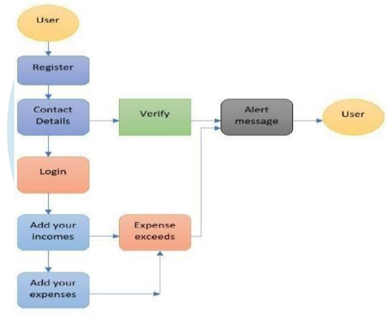

**Figure 3.1: Architecture Diagram**

* 1. **FLOW DIAGRAM**

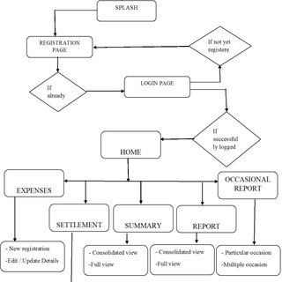

**Figure 3.2: Flow Diagram**

**3.3 UML Diagrams**

**USECASE DIAGRAM**

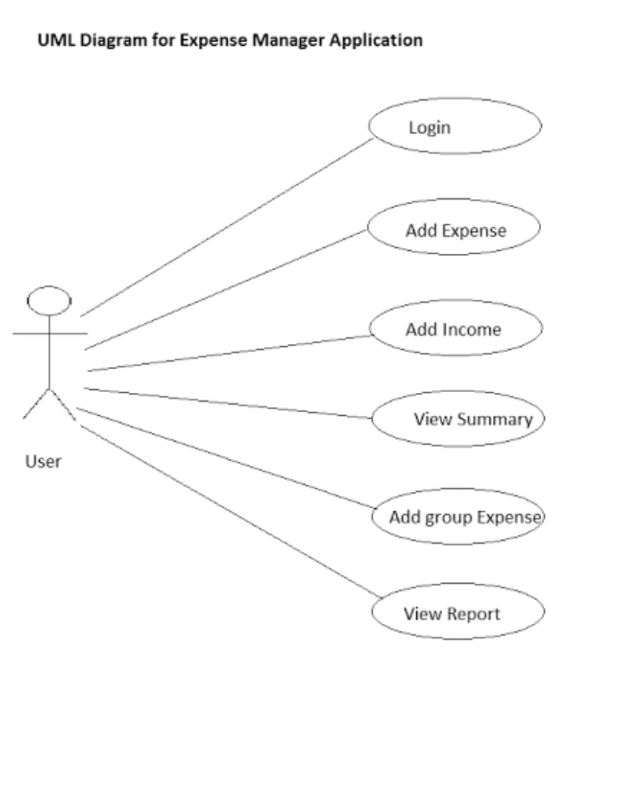

**ER DIAGRAM**

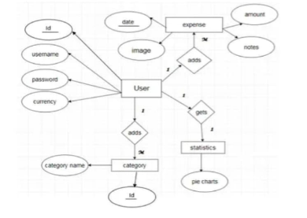

**Figure 3.4: ER Diagram**

**CLASS DIAGRAM**

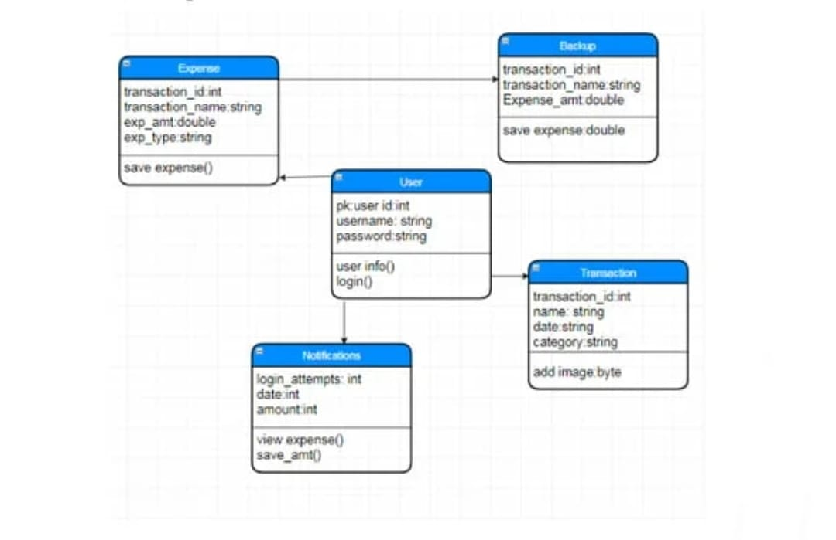

**Figure 3.5: Class Diagram**

**SEQUENCE DIAGRAM**

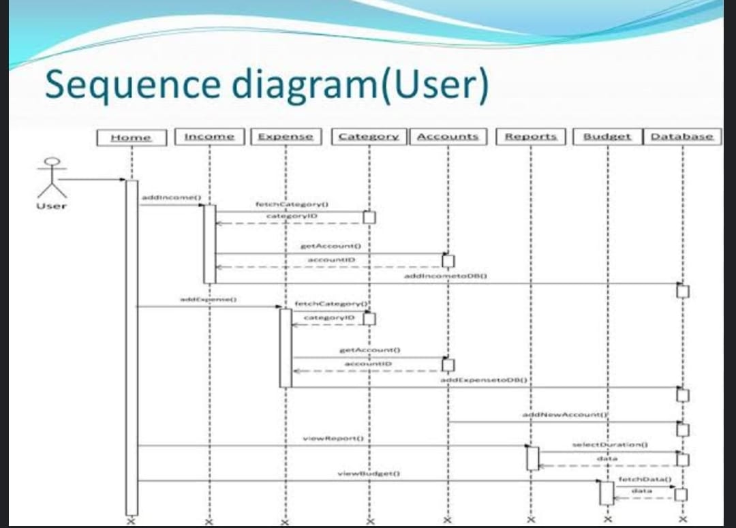

**Figure 3.6: Sequence Diagram**

**ACTIVITY DIAGRAM**

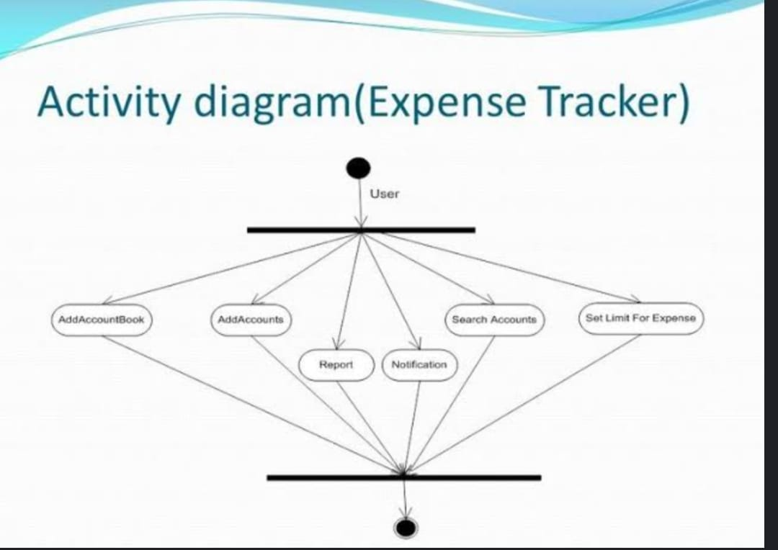

**Figure 3.7: Activity Diagram**

**CHAPTER-5**

**IMPLEMENTATION**

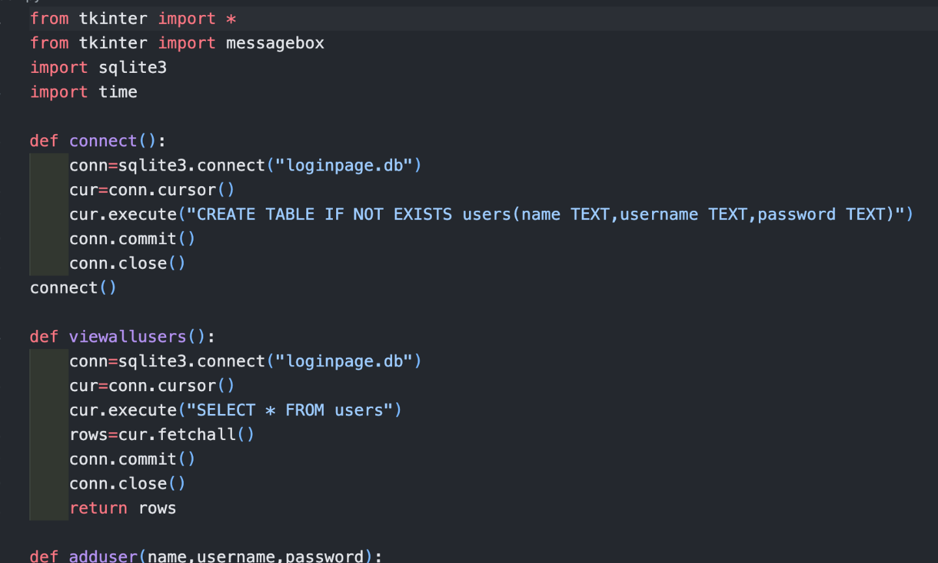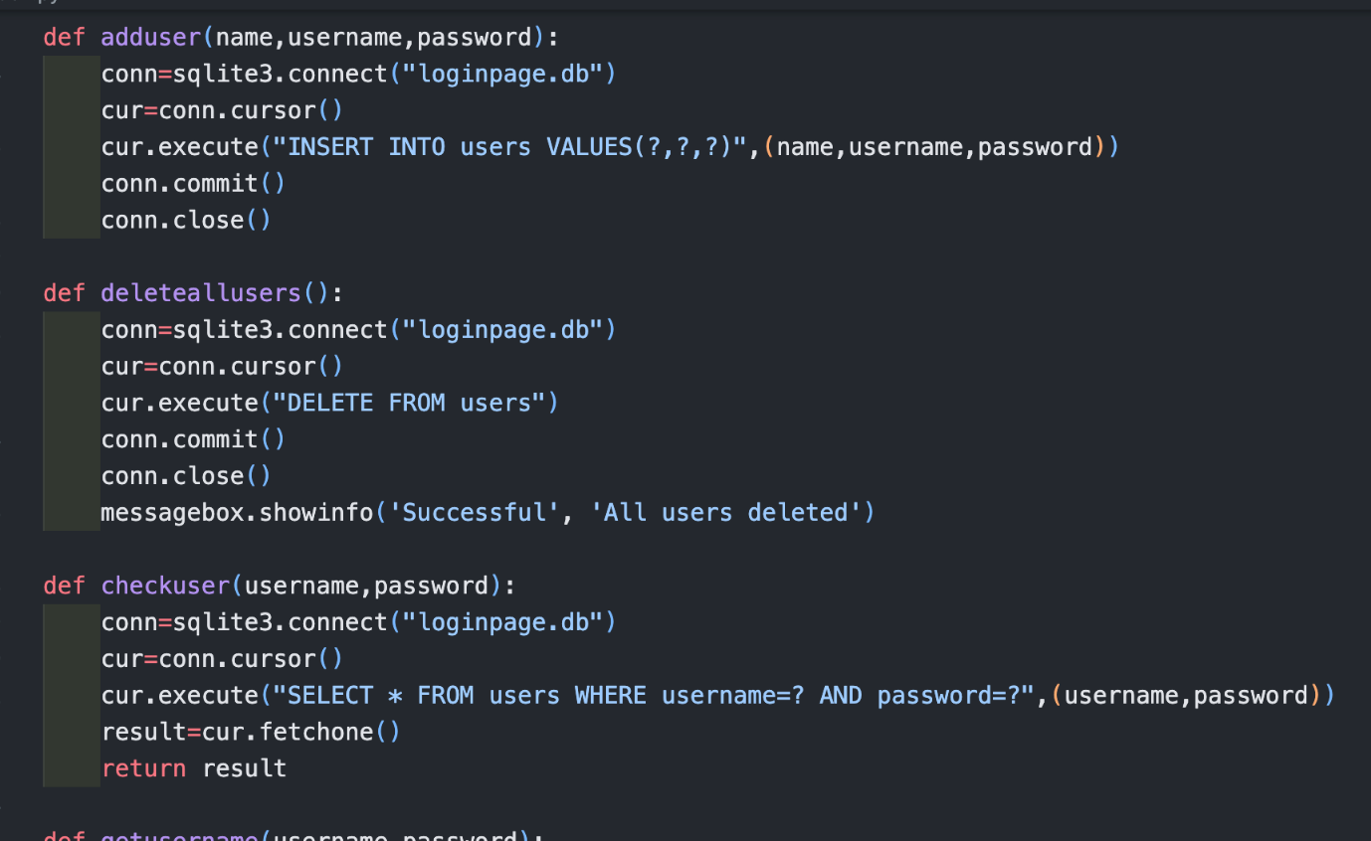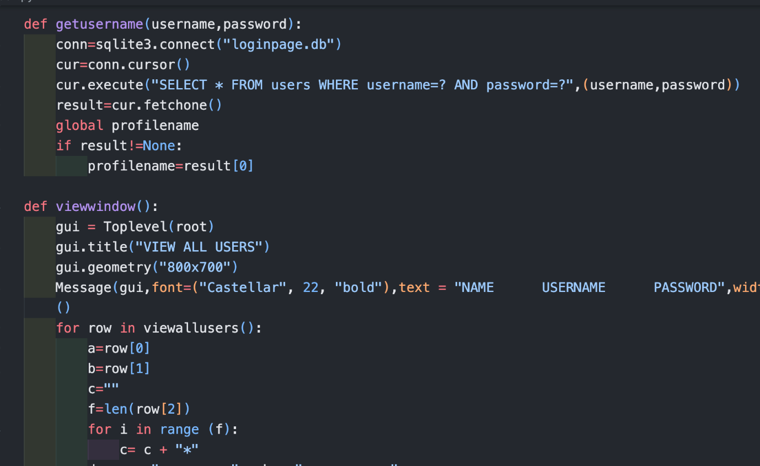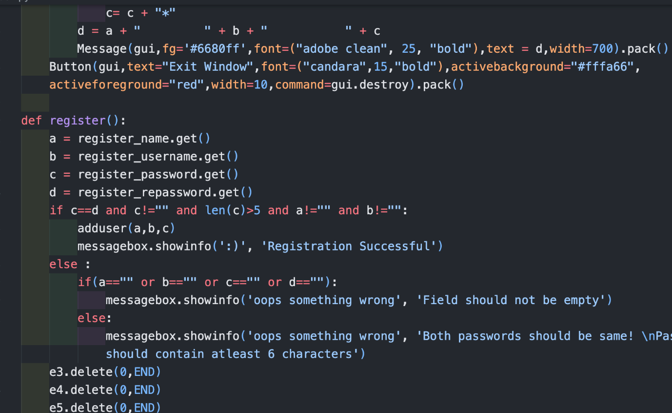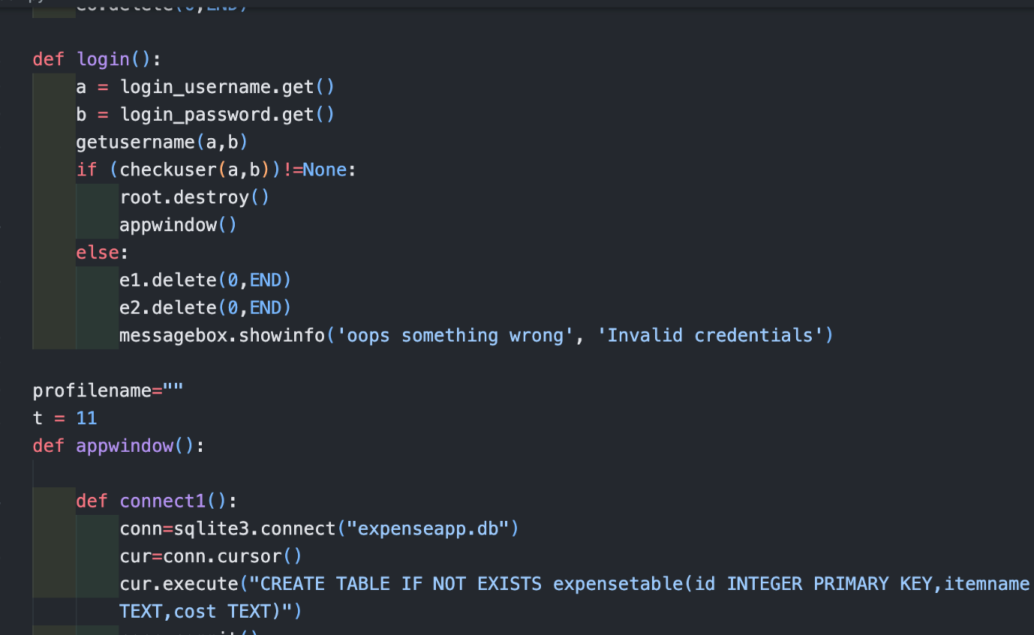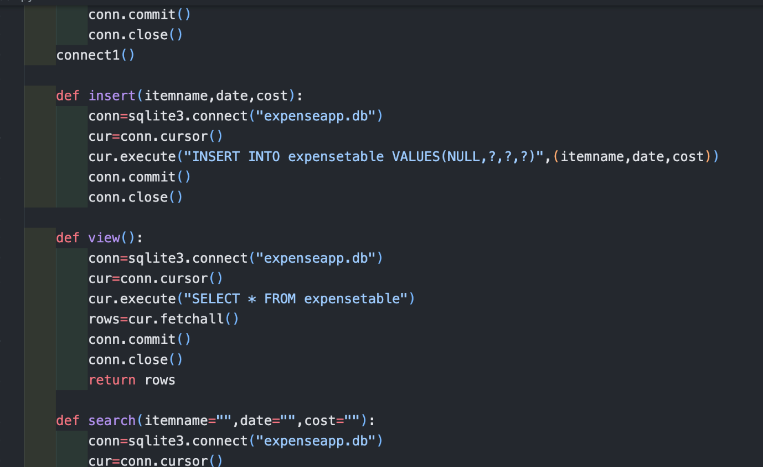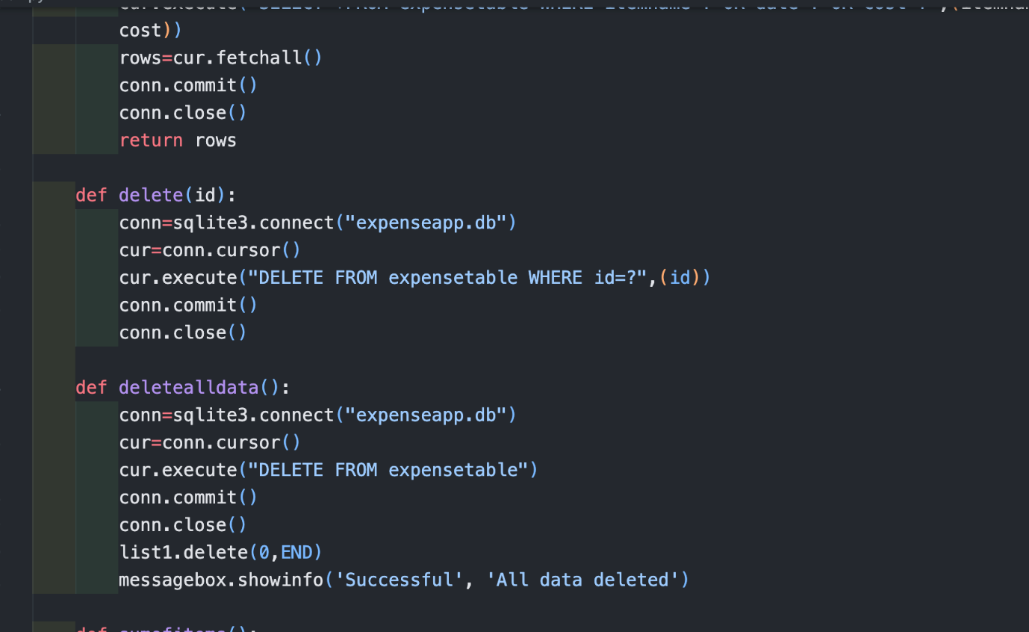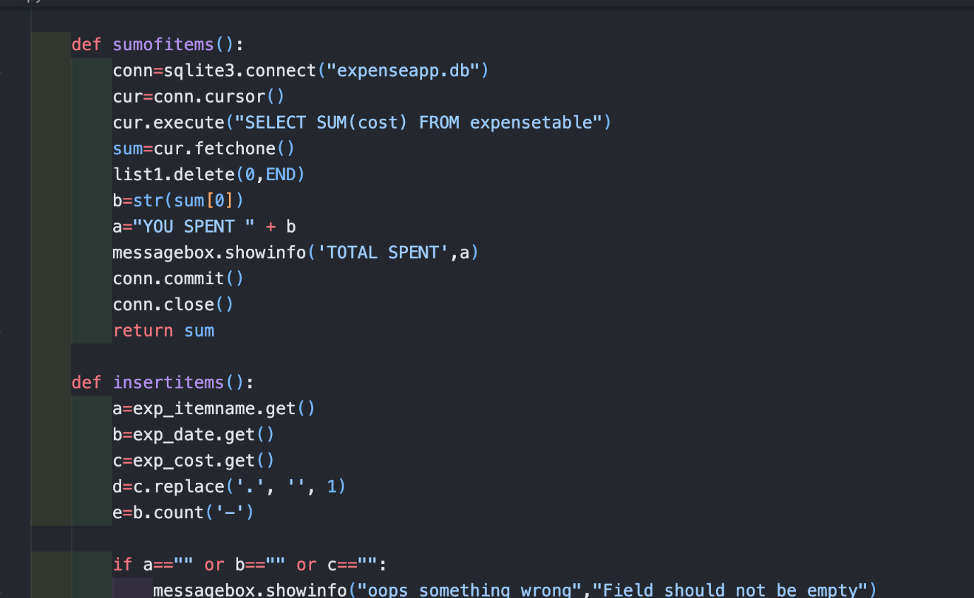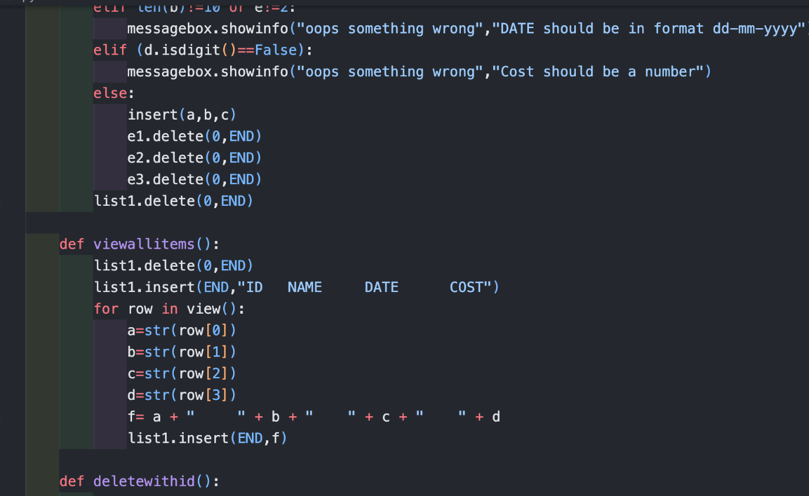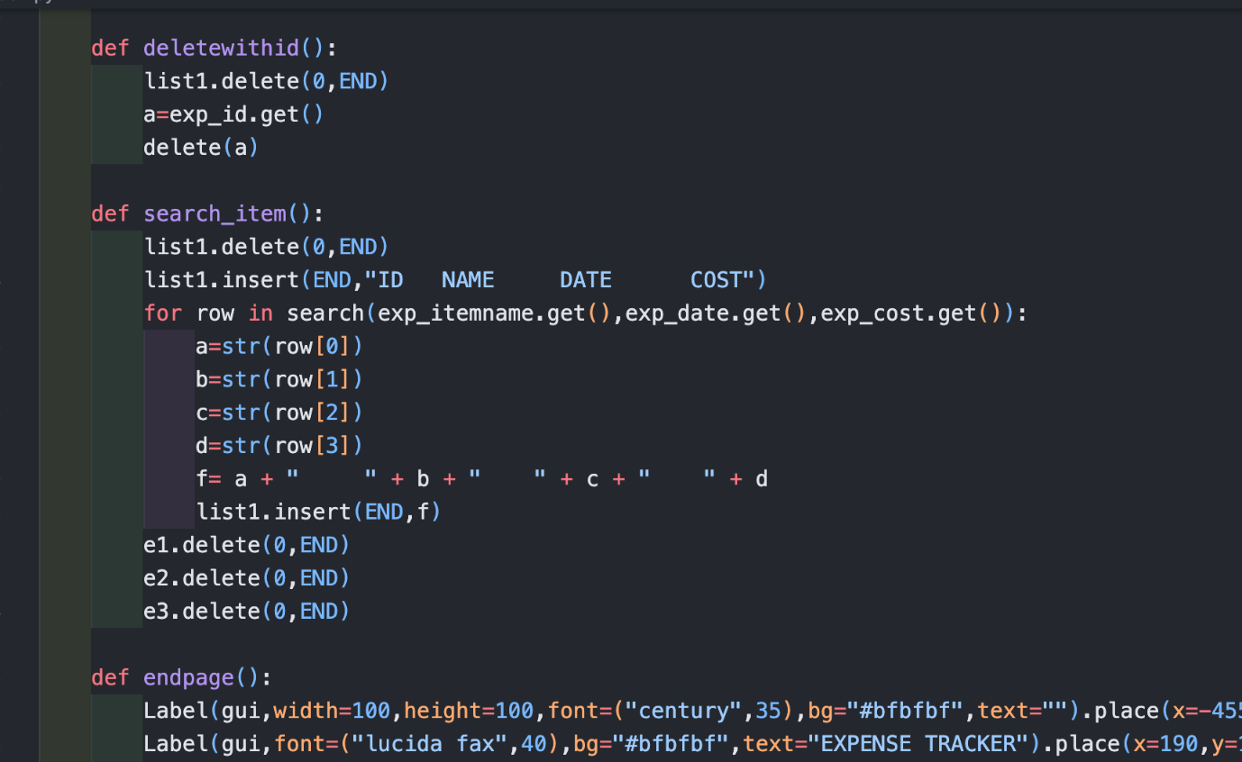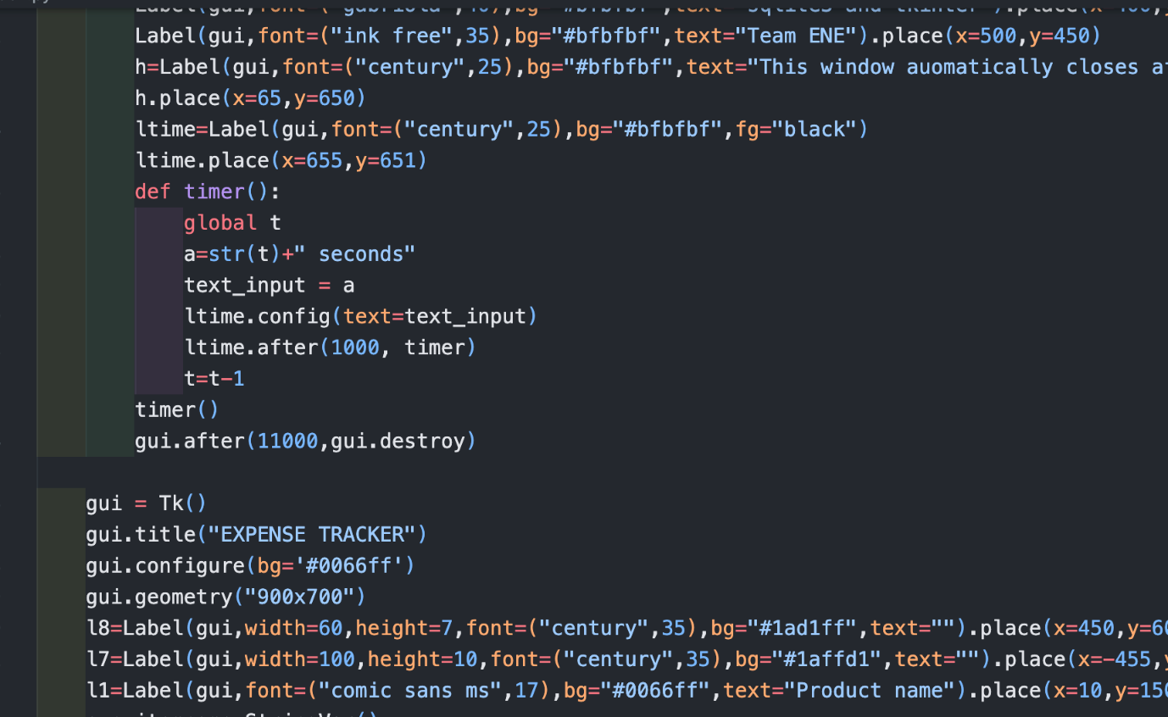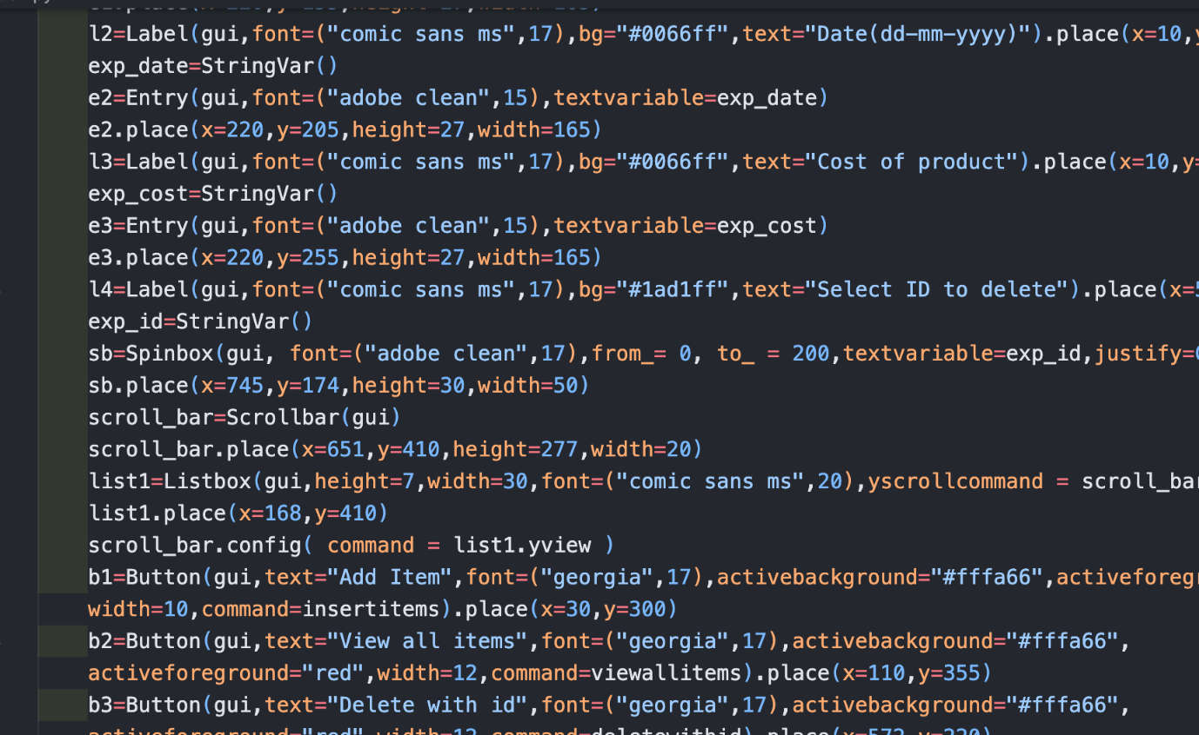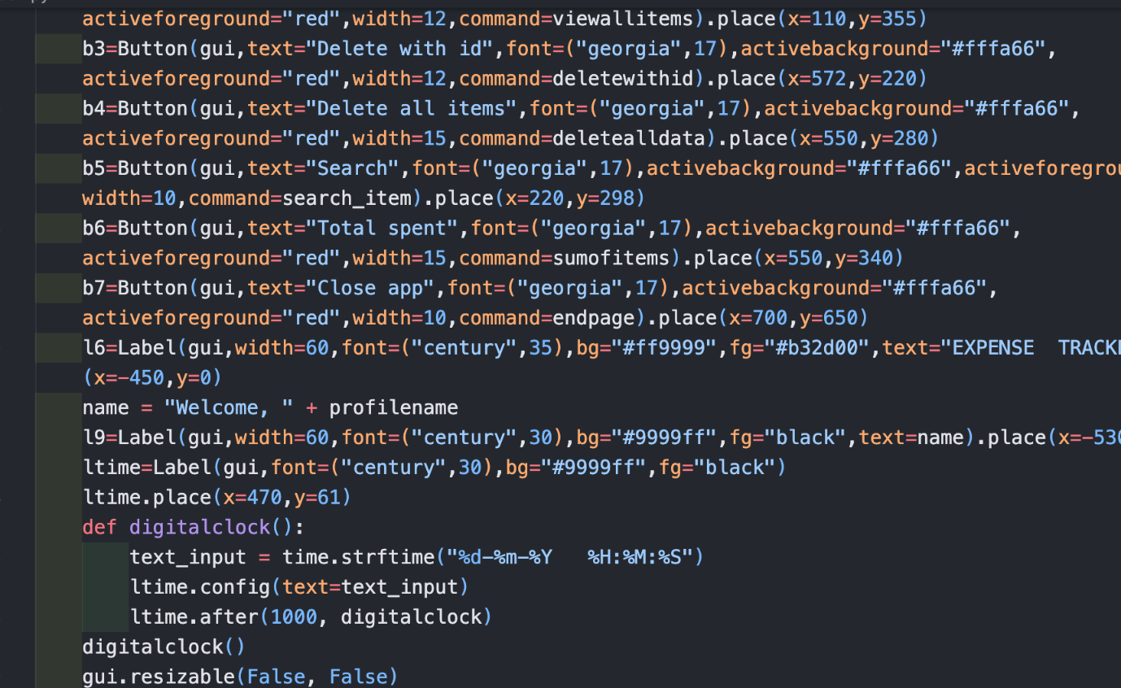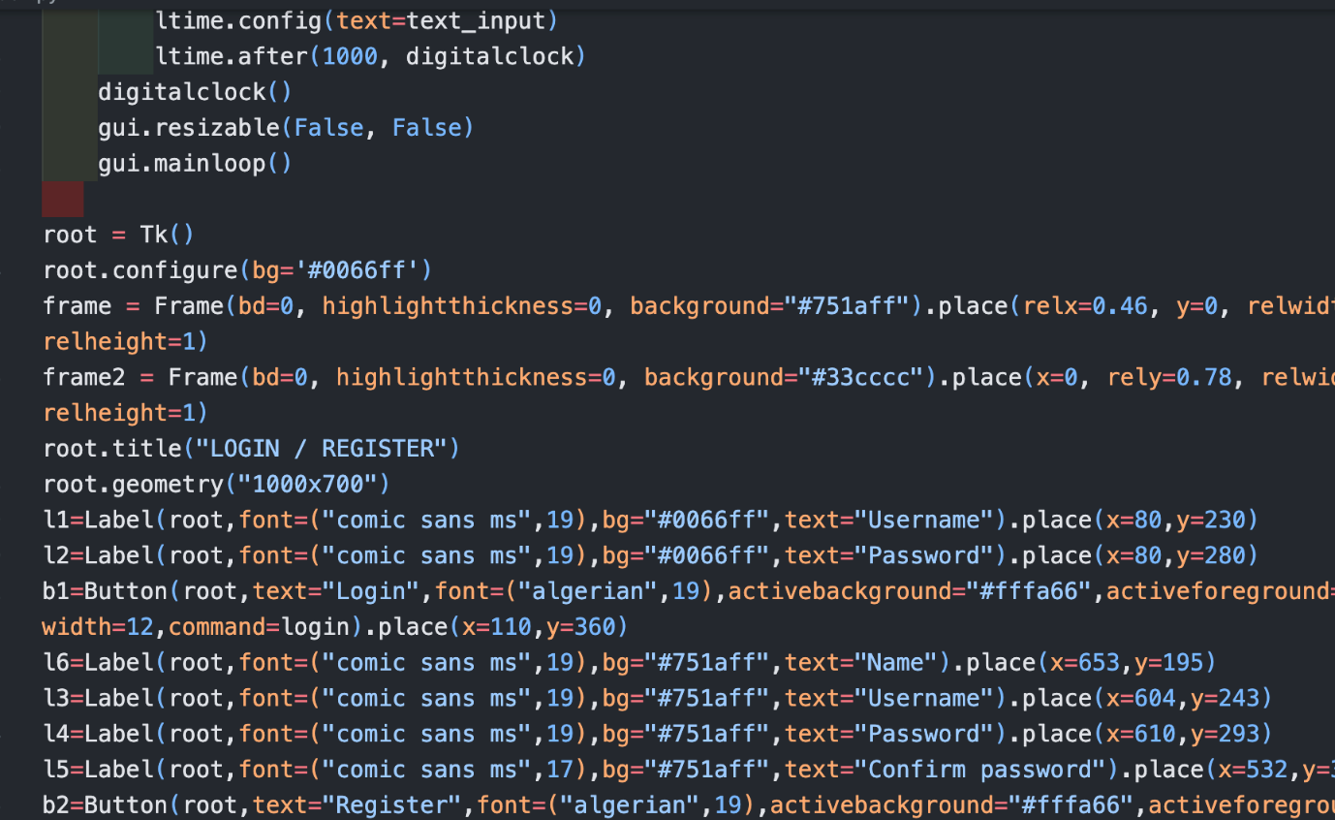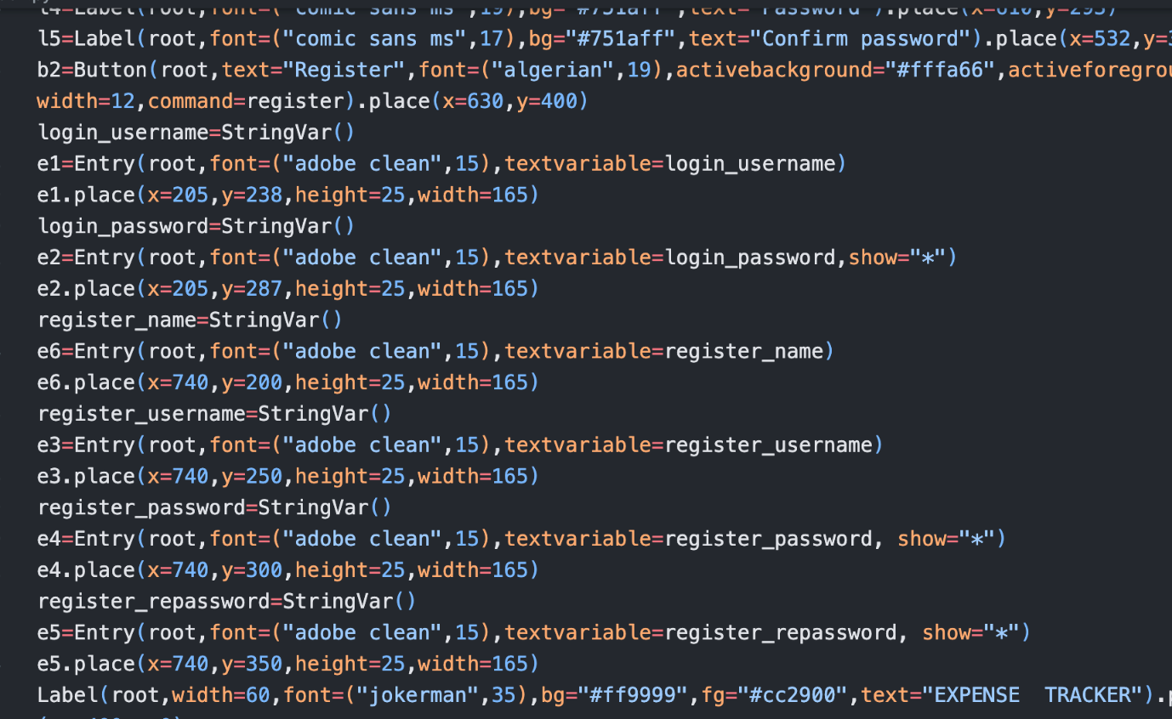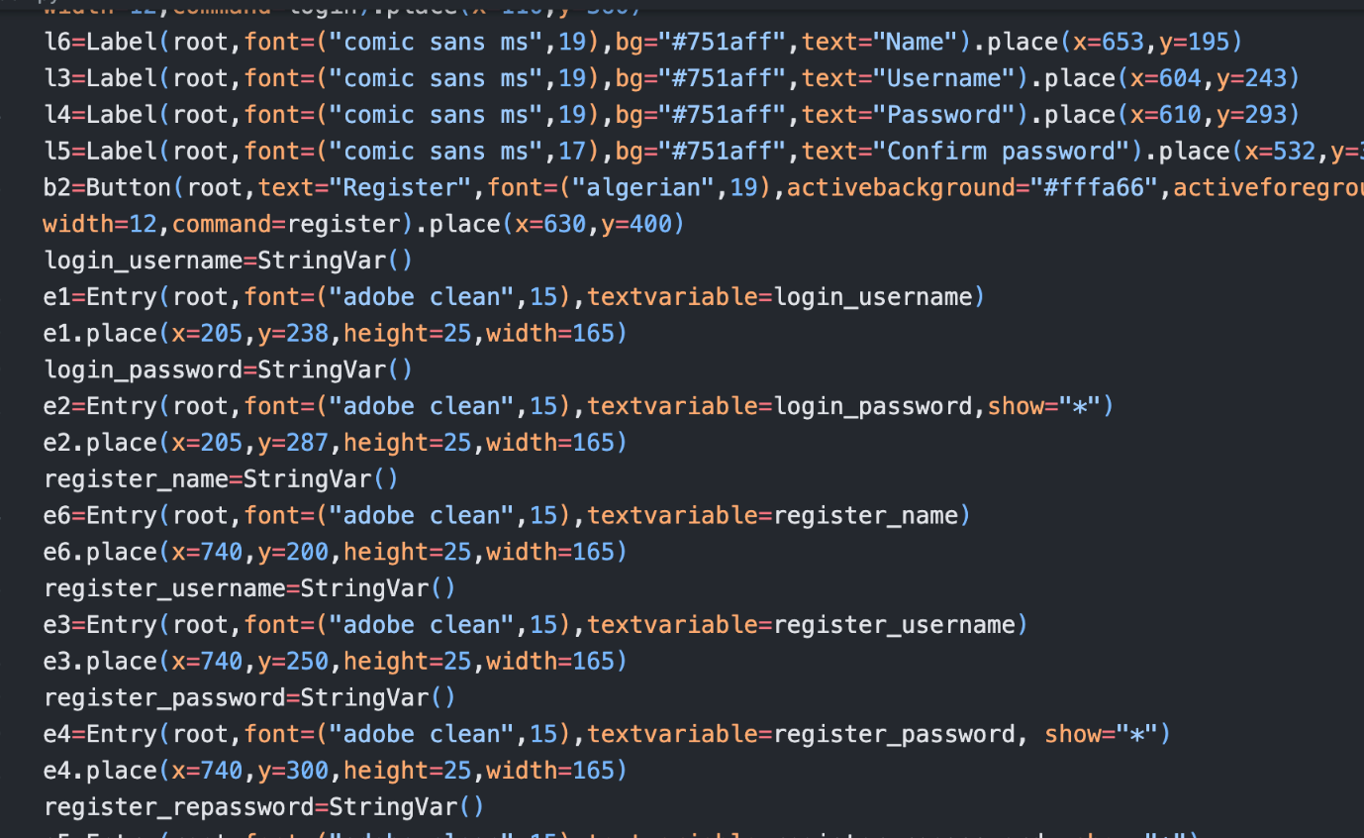

**CHAPTER-6**

**RESULTS AND DISCUSSION**

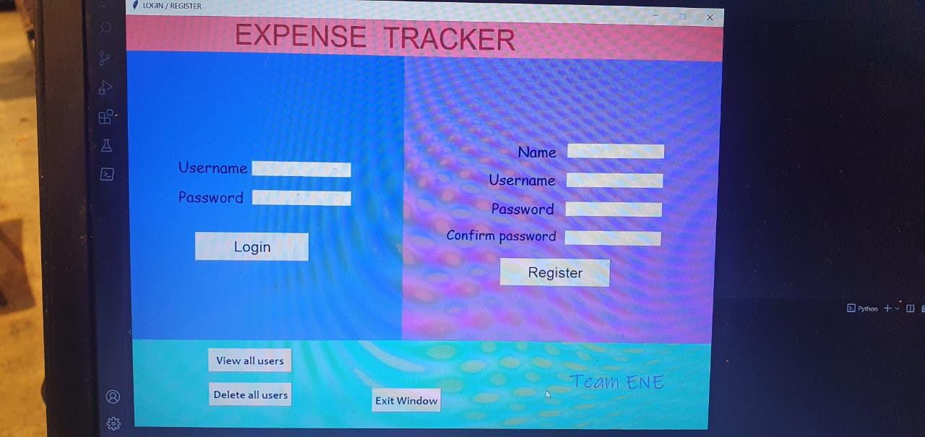

Figure 1Login Module

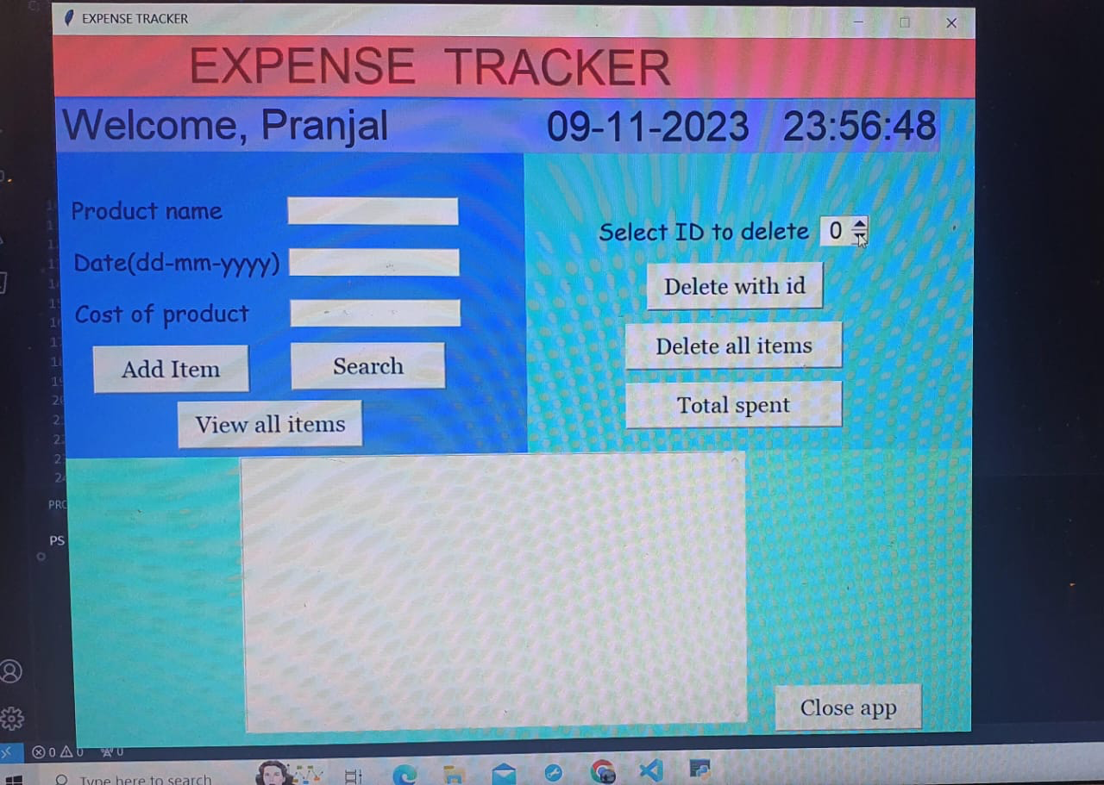

Figure 2Home Page

**CHAPTER-7**

**CONCLUSION**

**Conclusion:**

In conclusion, the Expense Tracker project represents a significant step towards efficient

and user-friendly personal finance management. The development journey involved

overcoming various challenges, resulting in a robust system that empowers users to track

and control their expenses effectively. The project's user-centric design, budget

management features, and emphasis on security contribute to its practicality and user

appeal.

**Key Achievements:**

User-Centric Design:

The project prioritizes a seamless user experience with an intuitive interface, making

expense tracking accessible to users of all levels of technical proficiency.

**Budget Management:**

The incorporation of a daily budget feature adds a proactive element to expense tracking,

helping users maintain financial discipline.

**Security Measures:**

The implementation of robust security measures ensures the protection of user data,

fostering trust and reliability in the system.

**Scalability and Performance:**

The project's architecture is designed to accommodate growth, ensuring scalability and

optimal performance even with increased user loads.

**Comprehensive Documentation:**

Extensive documentation facilitates ease of use for end-users and provides valuable

resources for developers maintaining or extending the system.

**Challenges and Learning:**

The development process presented challenges that enriched the team's knowledge and

expertise. Overcoming hurdles in database design, frontend-backend integration, and

ensuring system reliability contributed to the team's growth.

**Future Enhancements:**

The Expense Tracker project lays the foundation for future improvements and extensions.

Potential enhancements include:

**Mobile Application:**

Developing a mobile application version would enhance accessibility, allowing users to

manage expenses on-the-go.

**Integration with Financial Institutions:**

Integrating the system with financial institutions could automate the expense tracking

process by importing transaction data directly.

**Advanced Reporting Features:**

Implementing advanced reporting and data visualization features would provide users with

deeper insights into their spending patterns.

**Machine Learning for Predictive Analysis:**

Incorporating machine learning algorithms for predictive analysis could forecast future

expenses based on historical data, aiding users in better financial planning.

**Expense Categories and Tags:**

Adding customizable expense categories and tags would provide users with more granular

control over their spending analysis.

**Notification and Alert Customization:**

Allowing users to customize notifications and alerts based on spending thresholds or

specific expense categories would add a personalized touch.

**Multi-User Support:**

Introducing multi-user support could extend the application's utility to families or shared

households, facilitating collaborative expense tracking.

**Closing Thoughts:**

The Expense Tracker project, with its current features and the potential for future

enhancements, is not just a tool for managing expenses but a dynamic platform for financial

empowerment. As users continue to benefit from its functionalities, the project team

remains committed to refining and expanding the system to meet evolving user needs and

technological advancements. The journey doesn't end with the conclusion; it opens doors

to a future where personal finance management is intuitive, insightful, and tailored to

individual preferences.

**CHAPTER-8**

**REFERENCES**

[1]

https://ijarsct.co.in/Paper391.pdf

[2]

https://www.coursehero.com/file/33479765/Expense-Tracker-Experiment-No-1docx/

[3]

https://www.ijrti.org/papers/IJRTI2305187.pdf

[4]

https://www.bca.co.id/en/informasi/Edukatips/2023/03/20/03/57/manfaat-mencatat-pengeluaran-yang-perlu-kamu-ketahui#:~:text=Keeping%20track%20of%20expenses%20is,allocated%20for%20saving%20or%20investment..

[5]

https://www.scribd.com/document/369482136/Final-Report-Personal-Expense-Tracker-537

[6] Bi L, Kim J, Kumar JA, et al. Automatic liver lesion detection using cascaded deep residual networks. 2017, arXiv preprint arXiv:1704.0270.

[7] He K, Zhang X, Ren S, Sun J. Identity mappings in deep residual networks. In: European conference on computer vision. Cham: Springer; 2016, p. 630–45, (9908).

[8] Han X. Automatic liver lesion segmentation using a deep convolutional neural network method. 2017, arXiv:1702.05747.

[9] Korabelnikov AN, Kolsanov AV, Chaplygin SS, Zelter2 PM, Bychenkov3 KV, Nikonorov AV. Liver tumor segmentation CT data based on alexnet-like convolutional neural nets. Inf Technol Nanotechnol (ITNT-2016) 2016;348–56.

[10] Bellver M, Maninis K-K, Giró-I-Nieto X, Torres J, Van Gool L. Detection-aided liver lesion segmentation using deep learning. 2017, arXiv:1702.05747.